**Simulation-5**

**Aim: Application of MATLAB for the design of different types of choppers (type A, type B, type C and type D).**

**Software Required**

* MATLAB SIMULINK

**Theory:**

**What is a Chopper?**

A chopper converts a fixed D.C voltage voltage to a variable D.C voltage. Hence, these are also known as DC to DC converters. In order to turn offf the thyristor in chopper circuits forced commutation or load commutation is required as it does not undergo natural communation.The Applications of Choppers are: used in dc drives, subway cars, trolley buses, battery driven vehicles etc.

**Types of Choppers:**

* Type A Chopper (or) First Quadrant chopper
* Type B Chopper (or) Second Quadrant Chopper
* Type C Chopper (or) Two Quadrant Type A Chopper
* Type D Chopper (or) Two-Quadrant Type B Chopper

**Type A chopper or First Quadrant Chopper:**

This type of chopper is shown in the figure. It is known as first-quadrant chopper or type A chopper. When the chopper is on, v0 =VSas a result and the current flows in the direction of the load. But when the chopper is off v0is zero but I0continues to flow in the same direction through the freewheeling diode FD, thus average value of voltage and current say V0 and I0will be always positive as shown in the graph. In type A chopper the power flow will be always from source to the load. As the average voltage V0is less than the dc input voltage Vs~~.~~

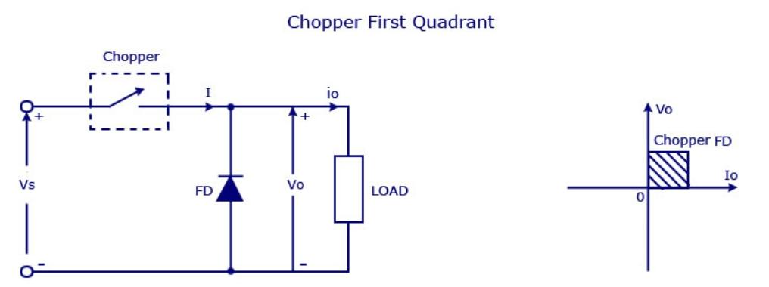

*Fig 1- Class A chopper circuit with first quadrant diagram*

**Type B Chopper or Second-Quadrant Chopper**

In type B or second quadrant chopper the load must always contain a dc source E .  When the chopper   is on, v0  is zero but the load voltage E drives the current through the inductor L and the chopper, L stores the energy during the time Tonof the chopper. When the chopper is off, v0=( E+ L .  *di*/*dt )* will be more than the source voltage  Vs. Because of this the diode D2 will be forward biased and begins conducting and hence the power starts flowing to the source.  No matter the chopper is on or off the current I0  will be flowing out of the load and is treated negative . Since VO is positive and  the current I0 is negative , the direction of power flow will be from load to source. The load voltage V0 = (E+L*.di*/*dt )*  will be more than the voltage Vs  so the  type B chopper is also known as a step up chopper .

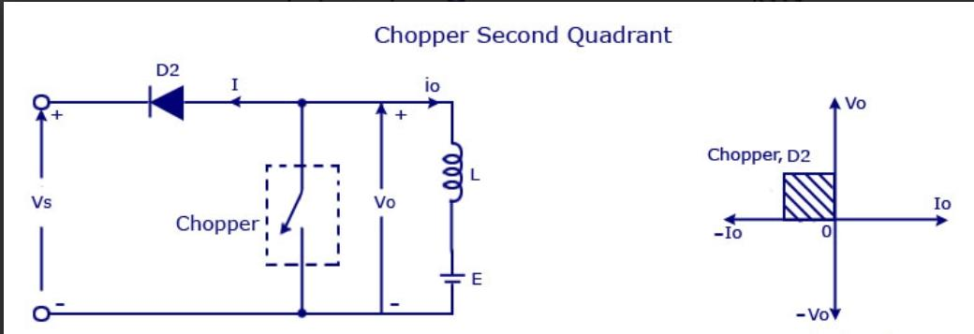

*Fig 2- Class B chopper circuit with second quadrant diagram.*

**Type -C chopper or Two-quadrant type-A Chopper**

Type C chopper is obtained by connecting type –A and type –B choppers in parallel.  We will always get a positive output voltage V0 as the freewheeling diode FD is present across the load.  When the chopper is on the freewheeling diode starts conducting and the output voltage v0 will be equal to Vs. The direction of the load current i0will be reversed. The current i0 will be flowing towards the source  and   it will be positive regardless the chopper is on or  the FD conducts.  The load current will be negative if the chopper is or the diode D2 conducts.  We can say the chopper and FD operate together as type-A chopper in first quadrant. In the second quadrant, the chopper and D2 will operate together as type –B chopper.

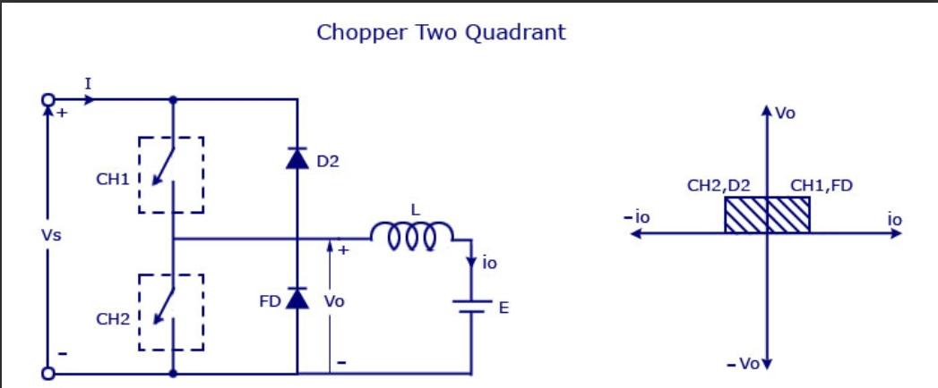

*Fig 3- Class C chopper circuit with second quadrant diagram.*

The average voltage will be always positive but the average load current might be positive or negative. The power flow may be life the first quadrant operation i.e from source to load or from load to source like the second quadrant operation.  The two choppers should not be turned on simultaneously as the combined action my cause a short circuit in supply lines. For regenerative braking and motoring this type of chopper configuration is used.

**Type D Chopper or Two-Quadrant Type –B Chopper**

The circuit diagram of the type D chopper is shown in the above figure. When the two choppers are on the output voltage  v0will be equal to Vs . When v0= – Vs the two choppers will be off but both the diodes D1 and D2 will start conducting. V0 the average output voltage will be positive when the choppers turn-on  the time Tonwill be more than the turn off time Toff its shown in the wave form below. As the diodes and choppers conduct current only in one direction the direction of load current will be always positive.

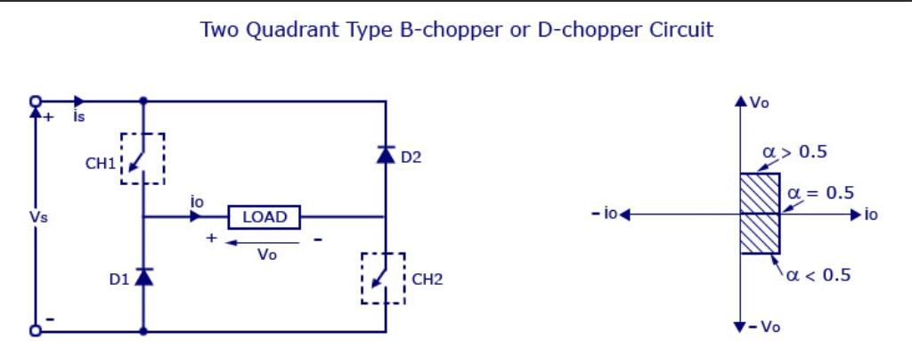

*Fig 2- Class D chopper circuit with second quadrant diagram.*

**Procedure:**

**Type A:**

* Firstly, MATLAB Simulink interface should be opened.
* Once, the Simulink is opened, one should open the power libraries in MATLAB.
* Once, the libraries are opened, a GTO, DC voltage source, Inductor, Resistor, diode, Voltage measurement, Pulse generator, current measurement, scope and Power Gui are chosen for designing a Type A chopper.
* The parameters of the above components are set to the needs of this simulation.
* All the above components are connected accordingly.
* After the connections are done, the circuit is simulated. For the output of the type A chopper, scope should be pressed. The scope is connected with the pulse generator, load current, load voltage and source volatge
* The output waveforms are obtained through the Scope.

**Type B:**

* Firstly, MATLAB Simulink interface should be opened.
* Once, the Simulink is opened, one should open the power libraries in MATLAB.
* Once, the libraries are opened, a GTO, DC voltage source, Inductor, Resistor, diode, Voltage measurement, GoTo tag, pulse generator, magnitude signal angle, scope, display and Power Gui are chosen for designing a Type B chopper.
* The parameters of the above components are set to the needs of this simulation.
* All the above components are connected accordingly.
* After the connections are done, the circuit is simulated, after which Goto tag B via magnitude signal angle is displayed as 0.0007001 and the Goto tag E via magnitude angle is displayed as 69.99. For the output of the type B chopper, scope should be pressed. The scope is connected with the Goto tags of B,C and E.
* The output waveforms are obtained through the Scope.

**Type C**

* Firstly, MATLAB Simulink interface should be opened.
* Once, the Simulink is opened, one should open the power libraries in MATLAB.
* Once, the libraries are opened, a GTO, DC voltage source, Inductor, Resistor, diode, Voltage measurement, Pulse generator, current measurement, scope and Power Gui are chosen for designing a Type C chopper.
* The parameters of the above components are set to the needs of this simulation.
* All the above components are connected accordingly.
* After the connections are done, the circuit is simulated. For the output of the type C chopper, scope should be pressed. The scope is connected with the pulse generator of GTO1 and GTO 2, load current, load voltage and source volatge
* The output waveforms are obtained through the Scope.

**Type D**

* Firstly, MATLAB Simulink interface should be opened.
* Once, the Simulink is opened, one should open the power libraries in MATLAB.
* Once, the libraries are opened, a GTO, DC voltage source, Inductor, Resistor, diode, Voltage measurement, Pulse generator, current measurement, scope and Power Gui are chosen for designing a Type D chopper.
* The parameters of the above components are set to the needs of this simulation.
* All the above components are connected accordingly.
* After the connections are done, the circuit is simulated. For the output of the type D chopper, scope should be pressed. The scope is connected with the pulse generator of GTO 1 and GTO 2, load current, load voltage and source voltage
* The output waveforms are obtained through the Scope.

**Circuit Simulated in MATLAB**

**Type A**

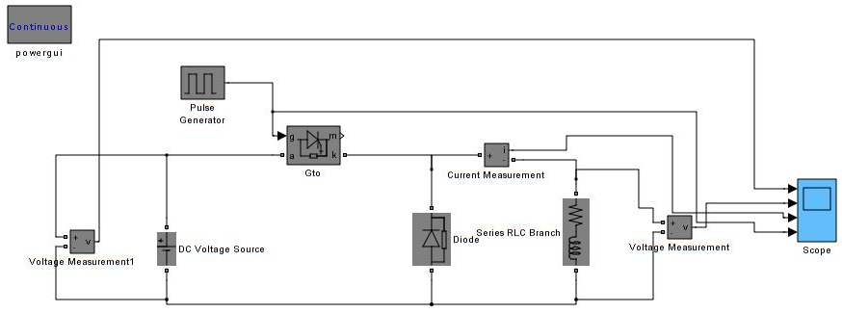

*Fig 5- SIMULINK circuit of Class A chopper .*

**Type B**

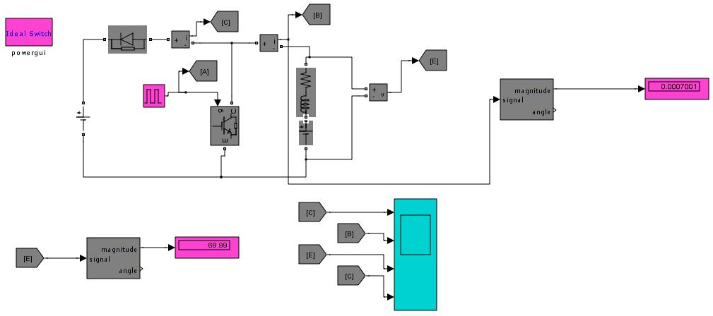

*Fig 6- SIMULINK circuit Class B chopper.*

**Type C**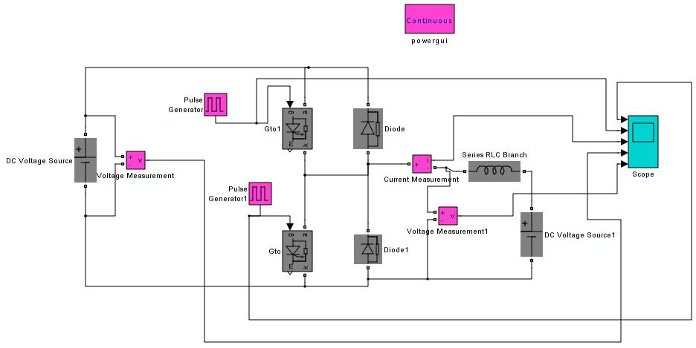

*Fig 7- SIMULINK circuit Class C chopper.*

**Type D**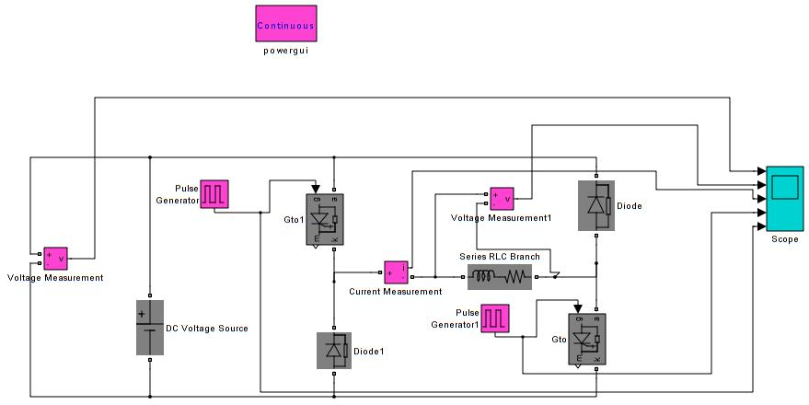

*Fig 8- SIMULINK circuit Class D chopper.*

**Output Waveforms obtained:Type A**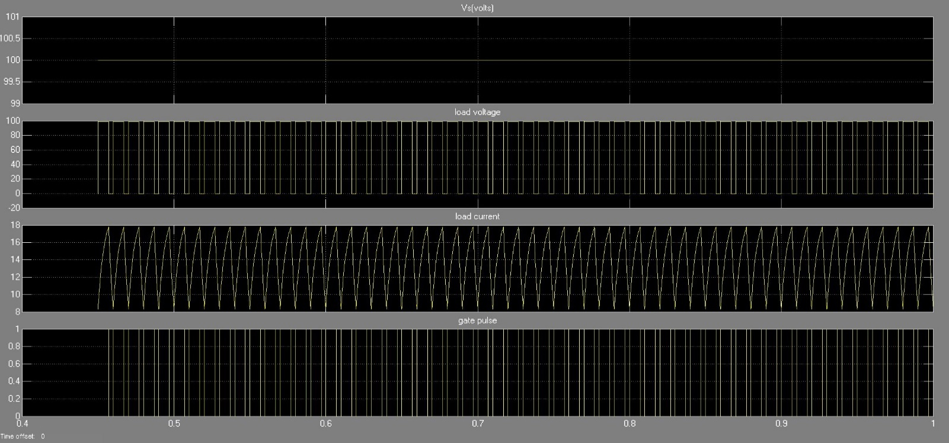

*Fig 9- SIMULINK Scope Output Class A chopper.*

**Type B**

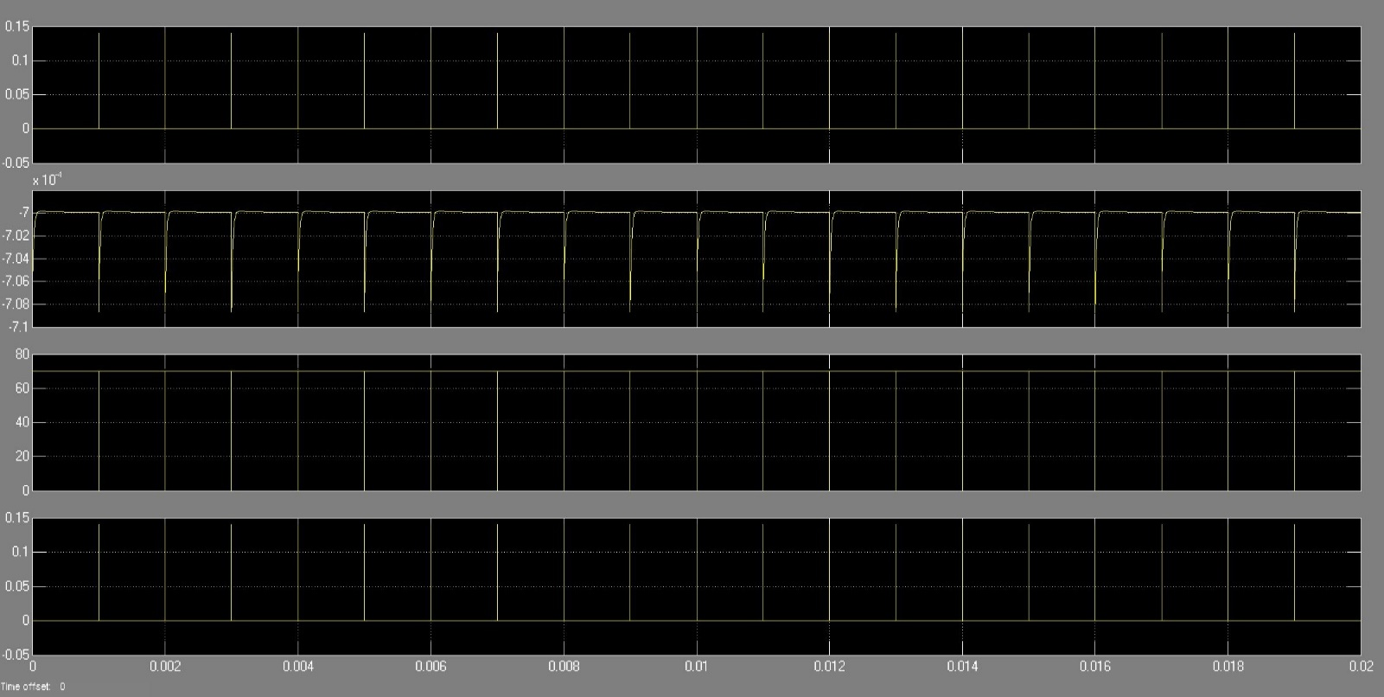

*Fig 10- SIMULINK Scope Output Class B chopper.*

**Type C**

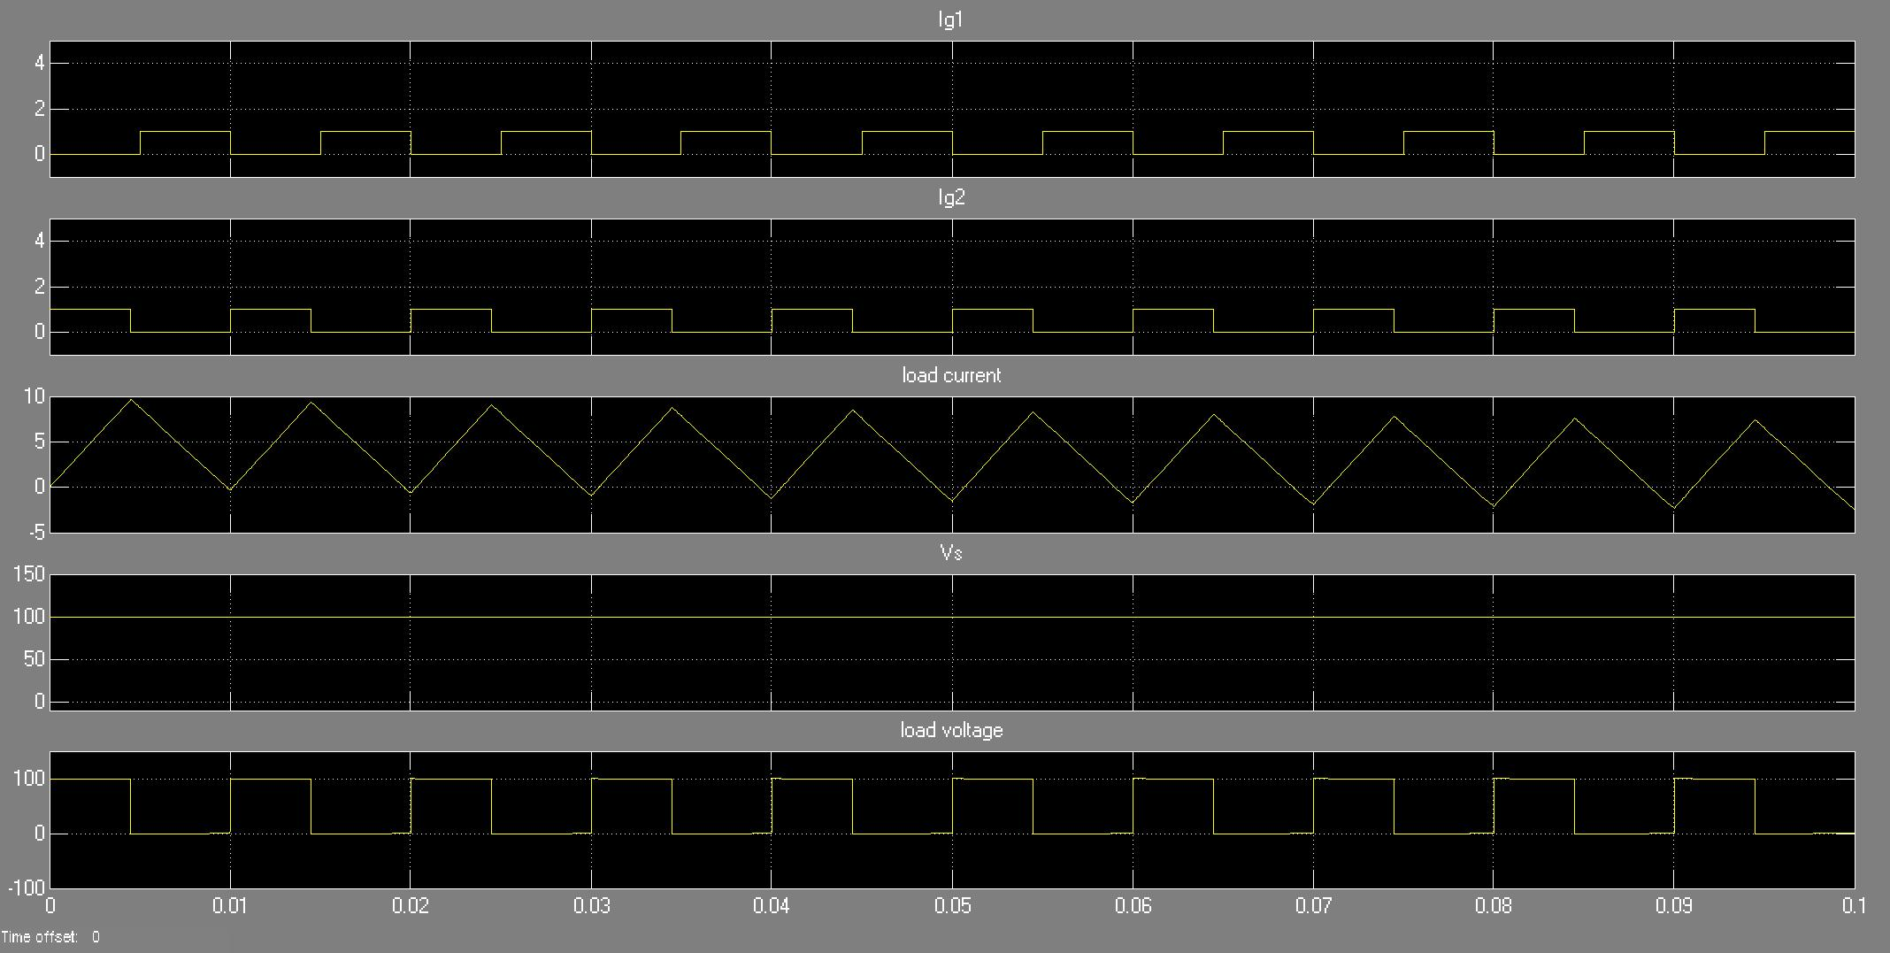

*Fig 11- SIMULINK Scope Output Class C chopper.*

**Type D**

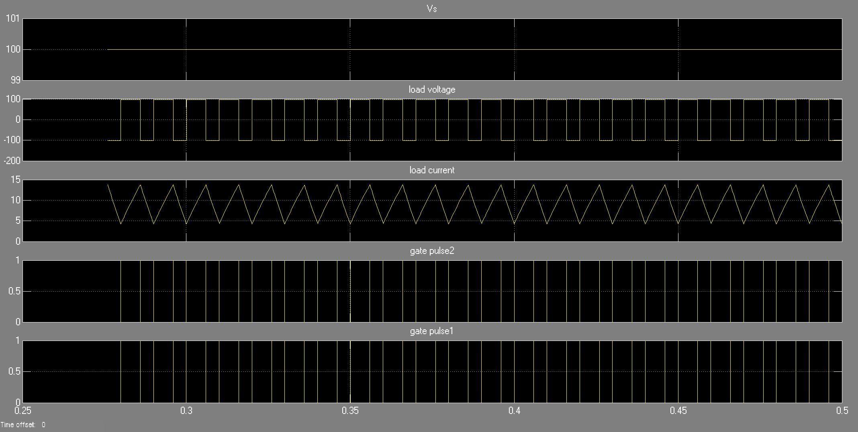

*Fig 12- SIMULINK Scope Output Class D chopper.*

**Result:**

The output of type A, type B, type C and type D choppers has been obtained in MATLAB Simulink and the result has been verified.